5.2.1 Definite Integral Worksheet

- Let A be the area of the region that lies under the graph and above the x-axis of between . Using right endpoints, find an expression for A as a limit.
We know the following:
Width of Rectangles | Right Endpoints | Height of Rectangles
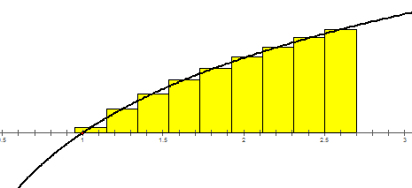
Therefore, we can say that:

- Use the definition of the definite integral to express as a limit.
We know the following:
Width of Rectangles | Right Endpoints | Height of Rectangles

- The area between the $x$-axis and the graph of on the interval can be written as a limit. Fill in the missing information in this limit so that the only variables appearing are n and i. You do not need to evaluate this limit.
We know the following:
Width of Rectangles | Right Endpoints | Height of Rectangles
- Determine a region whose area is equal to the limit . You do not need to evaluate the limit.

Width of Rectangles | Right Endpoints | Function Used

We can let .
This limit represents the area under the curve from .

- At time t seconds, the velocity of an object is given by the equation . The distance in feet traveled by this object from to can be written as a limit of Riemann sums in some different ways. Use your knowledge of Riemann sums to set up the following limits but do not evaluate them.

- Using a limit of right Riemann sums,

- Using a limit of left Riemann sums,

- Using a limit of midpoint Riemann sums,

- Evaluate the limit . Use proper notation throughout.

- Use the definition of the definite integral to write the integral as a limit. Then evaluate this limit.

We know the following:
Width of Rectangles | Right Endpoints | Height of Rectangles

So we work to evaluate

Therefore, we have found that:

- Use the definition of the integral to evaluate .
We know the following:
Width of Rectangles | Right Endpoints | Height of Rectangles

So we work to evaluate

Therefore, we have found that:

